Tucholsky, Dr. Kurt “Tucho” (1890-1935)

Kurt Tucholsky was an important and widely-read author, poet, satirist, and editor of small literary forms during the Weimar Republic. He was a prolific writer of satires, cabaret songs, and poems that bespoke the specific scenes of Berlin and Germany between the World Wars. Today he is widely known for two playful, erotic romances, *Rheinsberg* and *Schloß Gripsholm*, both of which he wrote after romantic weekend escapes with lovers. Tucholsky called for a radical renewal of German culture and society in his articles for the *Weltbühne* and the *Vossische Zeitung*, always adjusting his tone and argument with an eye to his audiences. After his military service in the First World War, Tucholsky became a powerful voice for bourgeois, left-wing humanism, and an active, antimilitarist, antifascist, anti-dogmatist, and enemy of demagogues. His use of transparent pseudonyms offered no protection against political and legal persecution, and his constant travels led him to live in Berlin, Paris, Denmark, and Sweden, where he settled and died of a narcotic overdose in a hospital in 1935.

MAIN ENTRY

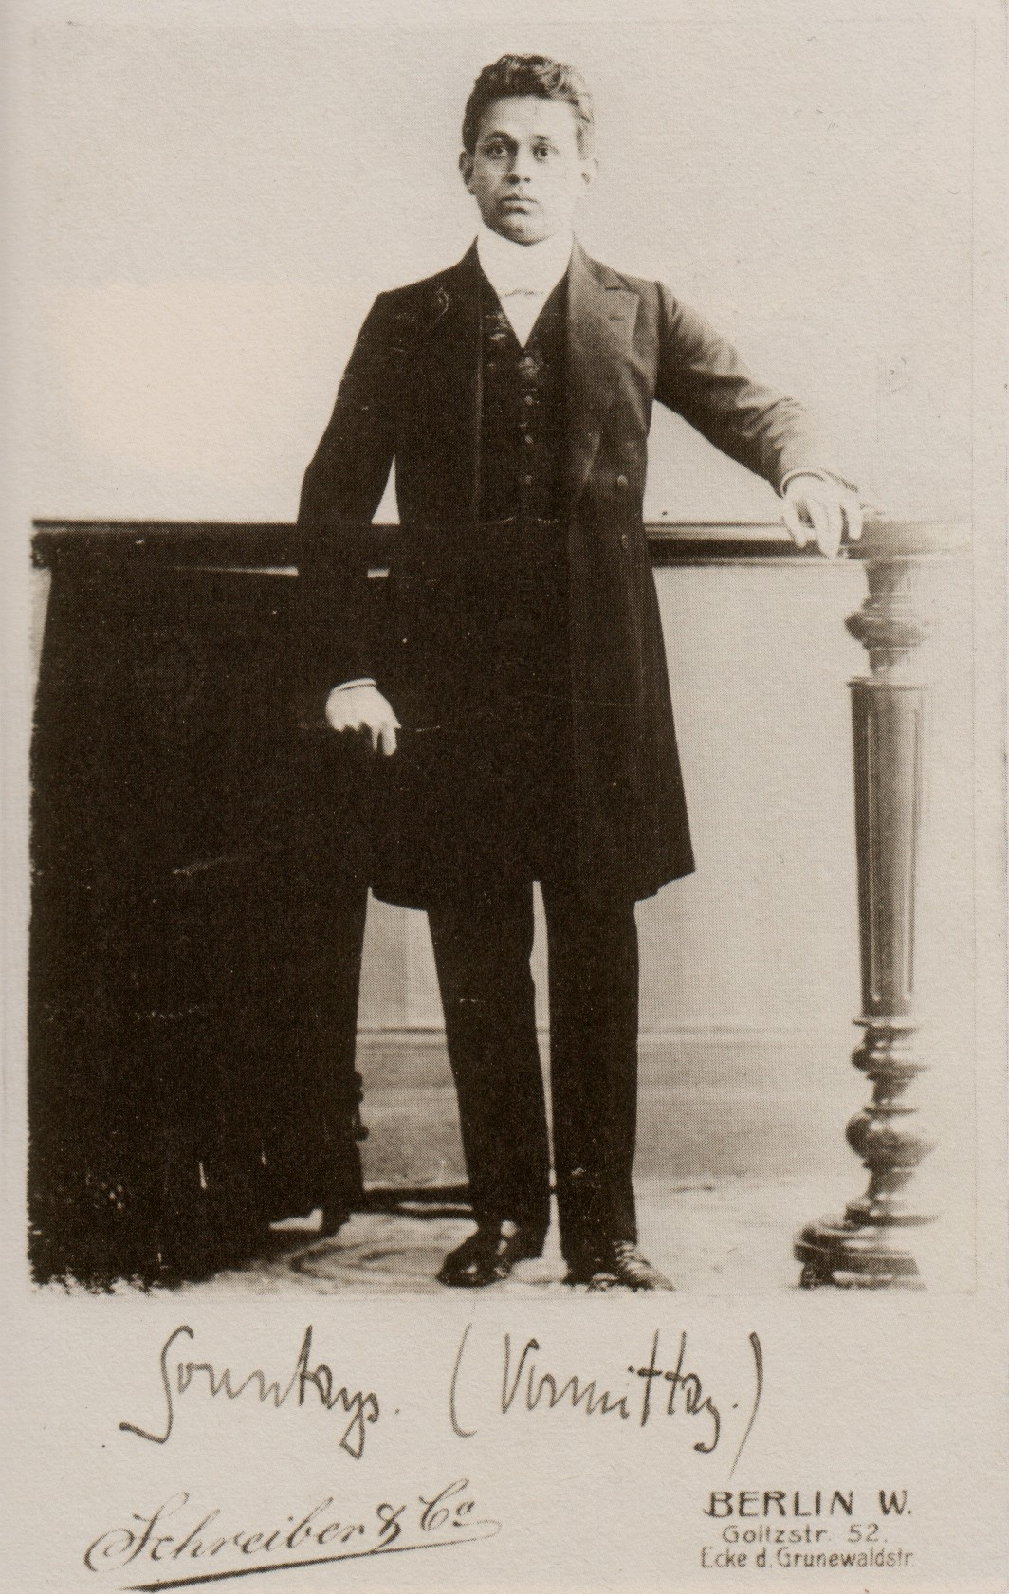Born in Berlin to Jewish merchants Alex and Doris Tucholsky, Kurt Tucholsky and his two younger siblings spent his childhood in Stettin (Szczecin), Poland. He later studied law in Berlin. Too busy writing to graduate, he completed his doctorate in 1915.

Over twenty-eight years, Tucholsky wrote ten books, a film script, and over three thousand essays, poems, and songs. A weekend in Rheinsberg with Else Weil in 1911 became the material for his first success, *Rheinsberg. Ein Bilderbuch für Verliebte* (1912), a playfully ironic and erotic novella with unconventional language. Tucholsky was drafted to the eastern front (first as a private and company clerk, then as sergeant of the secret military police in Rumania in 1918) and published a front paper, *Der Flieger*.

Portrait of Kurt Tucholsky, 1909 in Berlin "Sunday. (am.)"

[Source/rights: Kurt Tucholsky Literaturmuseum (CreativeCommons BY-NC-SA) URL: http://www.museum-digital.de/brandenburg/singleimage.php?imagenr=1672&inwi=1&w=1298&h=606]

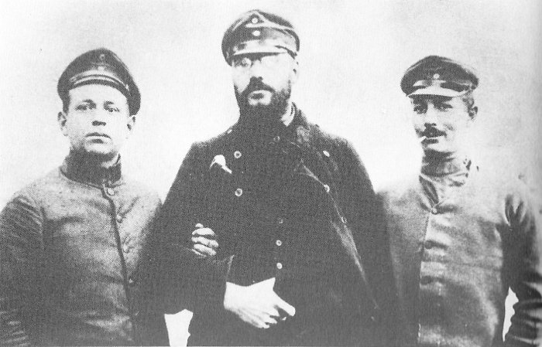

Tucholsky (left), Wilhelm L. Gruner (center), and Ludwig Pinner (right), 1915.

[Rights unknown. Source URL: http://www.hermannungar.com/images/University%201911-1918/slides/005c.html]

Tucholsky is famous for his political prose and character aliases (Kaspar Hauser, Peter Panter, Theobald Tiger, Ignaz Wrobel), his poetry, and songs. Back in Berlin, he wrote lyrics for Max Reinhardt’s cabaret, “Schall und Rauch,” songs for singers like Rosa Valetti, and published *Fromme Gesänge*. He first edited the satirical insert *Ulk*. After writing for Siegfried Jacobsohn since 1913, Tucholsky met him in 1919, and the editor became his mentor and friend.

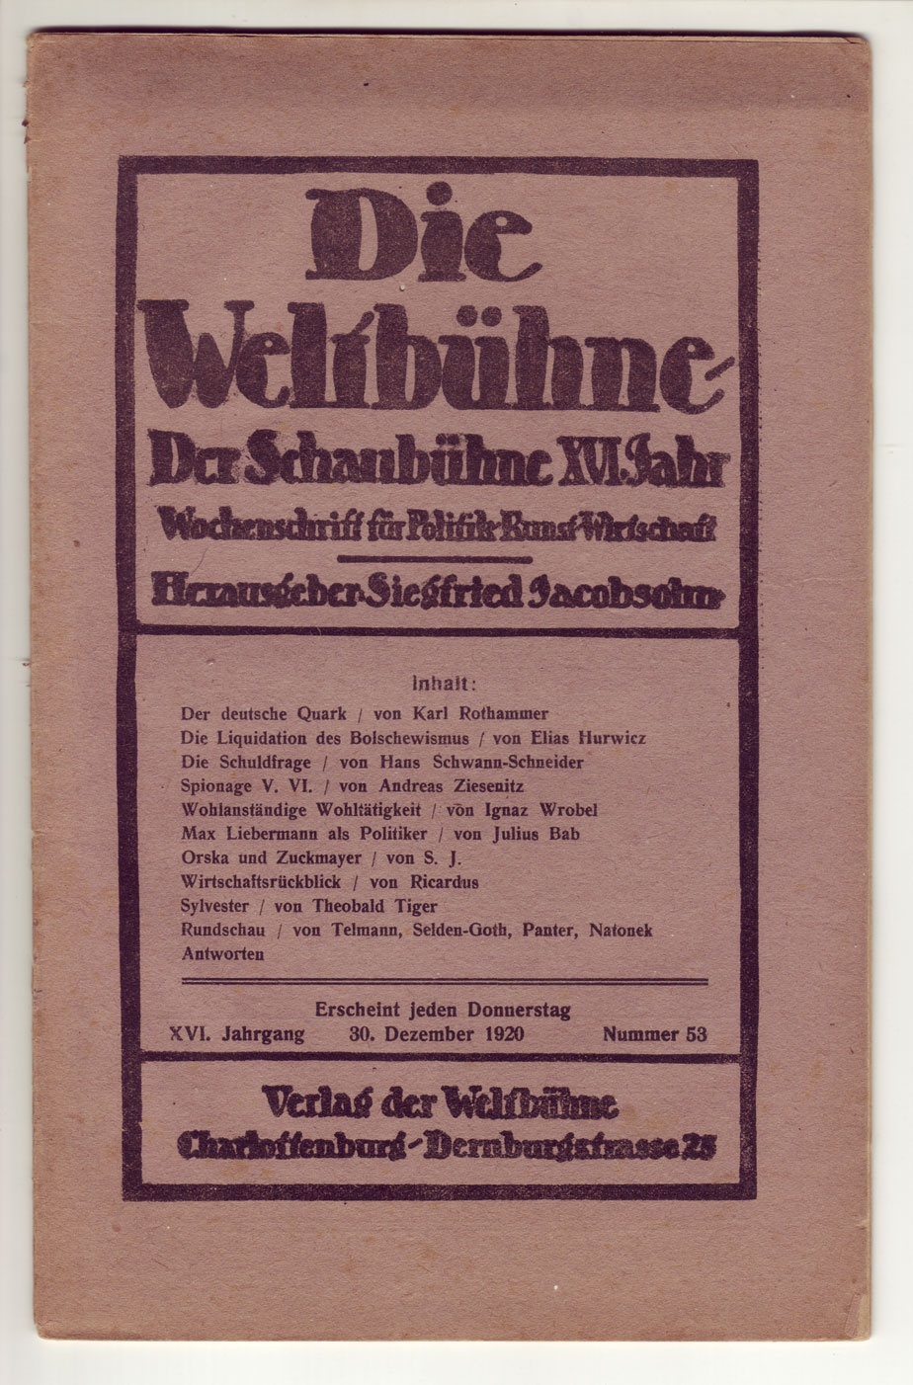

Issue 53, 30 December, 1920 of the Weltbühne, volume 16 of the paper originally called Schaubühne, published by Siegfried Jacobsohn, with three Tucholsky pieces.

[Source/rights: Kurt Tucholsky Literaturmuseum (CC BY-NC-SA) URL: http://www.museum-digital.de/brandenburg/index.php?t=objekt&oges=2418]

Jacobsohn’s *Weltbühne*, once a theater weekly, was the central venue of bourgeois, left-wing democrats during the Weimar Republic, and Tucholsky its most prolific author. Tucholsky’s 1919 programmatic “Wir Negativen” broke with the Wilhelminian spirit of Prussian Berlin by advocating a non-violent cultural and political revolution and, drawing on his war experiences, pacifist demilitarization. In 1920, he co-initiated the action committee “Never again War” and spoke at rallies. Though opposed to dogmatic party discipline, he became a freemason, joined the USPD, and wrote for party papers.

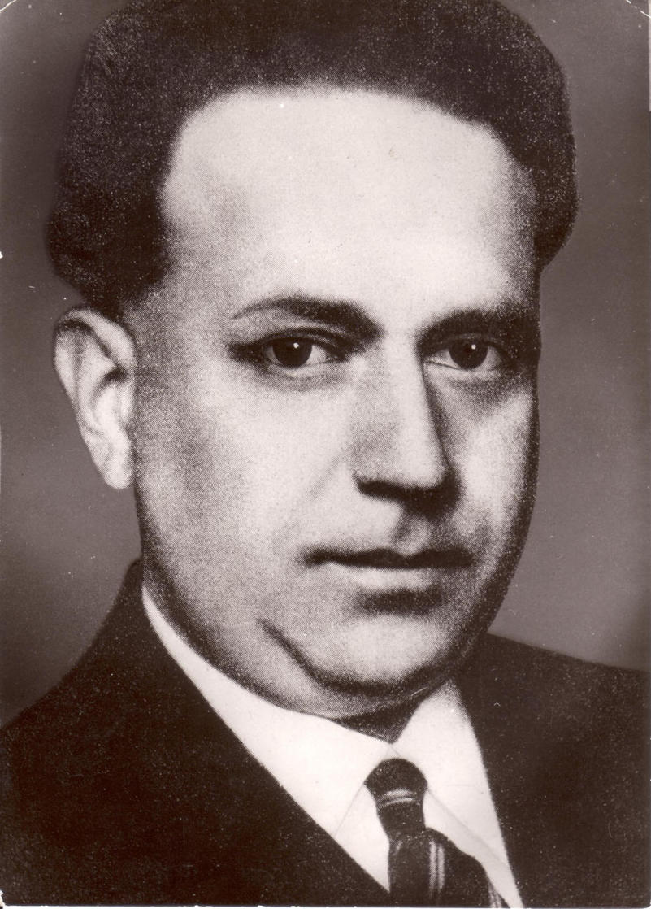

Kurt Tucholsky.

[Source: Bundesarchiv. URL: http://www.bundesarchiv.de/oeffentlichkeitsarbeit/bilder_dokumente/00859/index.html.de]

Besides his 1924 contract for the *Weltbühne*, he survived the hyperinflation as a bank secretary. He moved between Denmark, Paris, Zurich, and Berlin—even as the Paris foreign correspondent for the *Weltbühne* and *Vossische Zeitung* he spent only months at a time there.

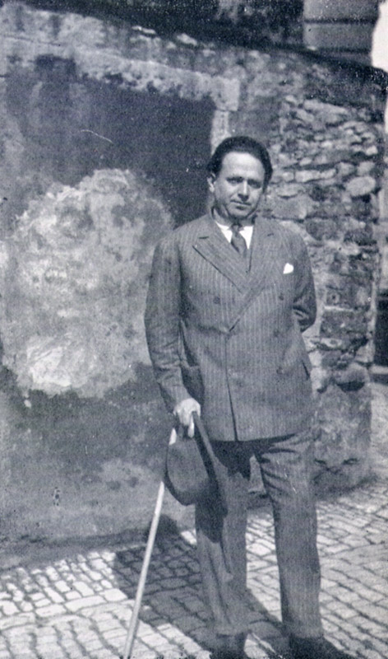

Jacobsohn died in 1926. Tucholsky acted as editor of the *Weltbühne* until Carl von Ossietzky took over. He also stayed politically engaged, speaking and writing for human rights and pacifist leagues. In 1926, he planned a new musical revue with Reinhardt and published a travelogue, *Ein Pyrenäenbuch*, his collection *Mit 5 PS*, and *Das Lächeln der Mona Lisa* in 1927-28.

Tucholsky moved to Sweden in 1929 and spent that summer with Lisa Matthias in Läggesta, near Castle Gripsholm. In 1931, he published another playful love novella, *Schloß Gripsholm. Eine Sommergeschichte*, a love story that pushed against sexual repression and language norms. Though more refined and darker than *Rheinsberg*, *Gipsholm* likewise resulted from Tucholsky’s turbulent love life.

Tucholsky in Paris, 1928.

[Rights: Sonja Thomassen, Lisa Matthias’ daughter who lives in Norway, authorized this picture for publication under GNU-FDL. URL: http://de.wikipedia.org/wiki/Kurt_Tucholsky#/media/File:TucholskyParis1928.jpg]

He had met Mary Gerold during the War, but their *amour fou* ended after she came to Berlin, and Tucholsky married Else Weil in 1920. In 1924, he divorced Weil and married Gerold, who left him when he met Lisa Matthias in 1927.

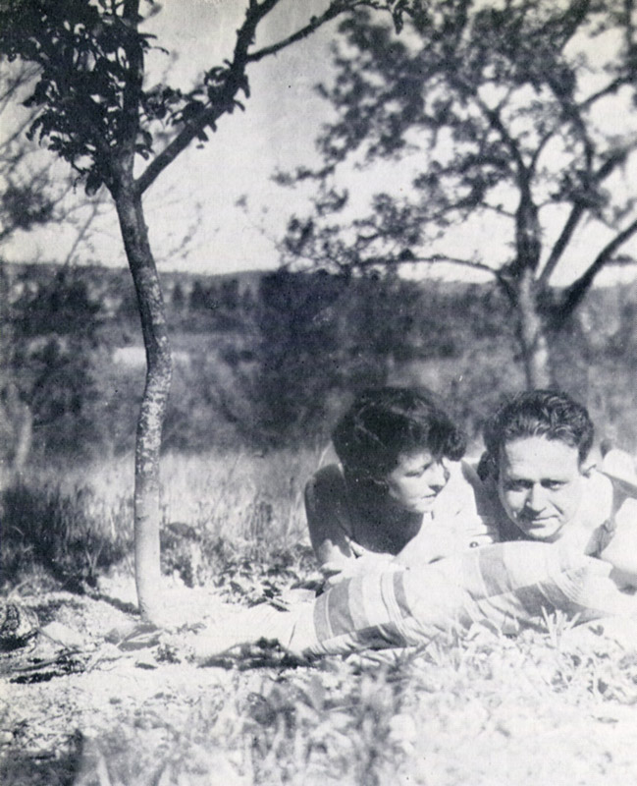

Kurt Tucholsky and Lisa Matthias Läggesta, Sweden, 1929.

[Rights: Sonja Thomassen, Lisa Matthias’ daughter who lives in Norway, authorized this picture for publication under GNU-FDL. URL: http://de.wikipedia.org/wiki/Schlo%C3%9F_Gripsholm_%28Roman%29#/media/File:TucholskyMatthiasLaeggesta.jpg]

Repeatedly sued for libel, breach of secrecy, even blasphemy, Tucholsky consistently won. Such aggressive persecution of authors accompanied the resurgence of reactionary, militarist nationalism of the 1930s. Tucholsky and John Heartfield reacted to imperialist-fascist threats in their 1929 satire picture book *Deutschland, Deutschland, über alles*.

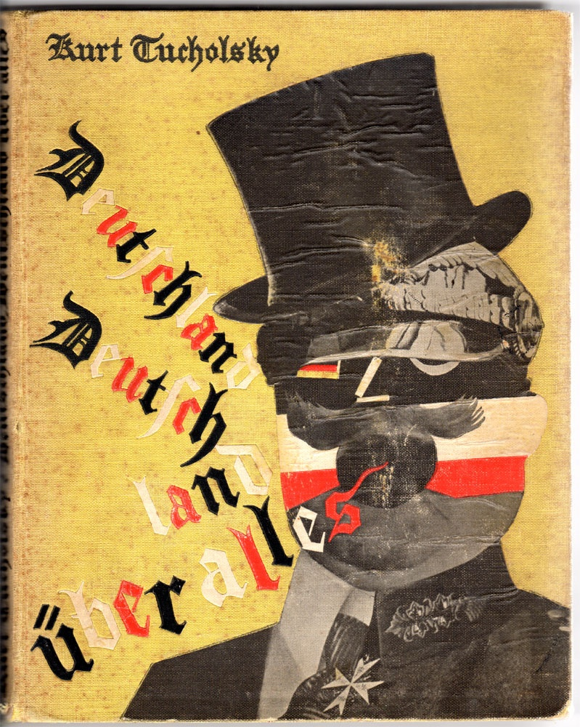

Cover of the first edition of Deutschland, Deutschland über alles by Kurt Tucholsky and John Heartfield (1929).

[Source/rights: Herkunft/Rechte: Kurt Tucholsky Literaturmuseum (CreativeCommons BY-NC-SA) URL: http://www.museum-digital.de/brandenburg/singleimage.php?imagenr=2659&inwi=1&w=1298&h=606]

In 1931, just before the infamous *Weltbühnen* trial, the Commander of the Armed Forces unsuccessfully pressed charges against an Ignaz Wrobel article containing the sentence “Soldiers are murderers.” In 1932, after *Lerne lachen ohne zu weinen* had appeared, Tucholsky wrote his last items for the *Weltbühne*, moved to Zurich, and underwent a series of surgeries for chronic nose problems that had plagued him for a decade.

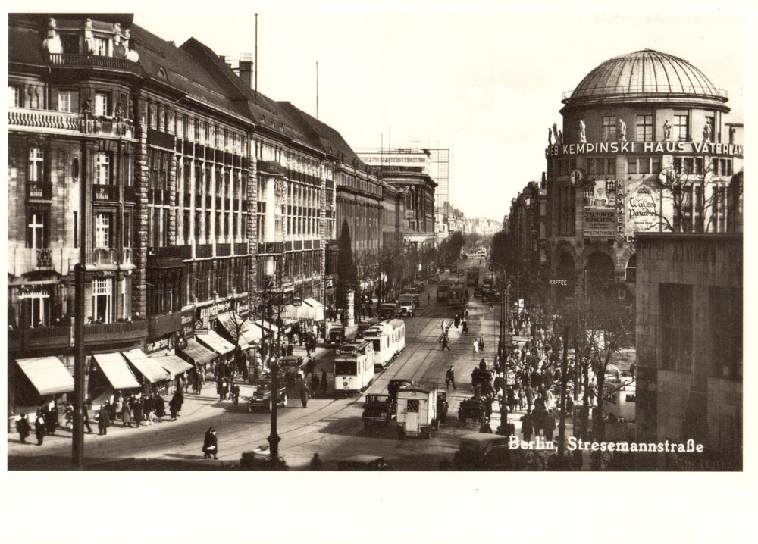

Postcard showing the Stresemannstraße, Berlin, ca. 1930.

[Source/rights: Kurt Tucholsky Literaturmuseum (CreativeCommons BY-NC-SA) URL: http://www.museum-digital.de/brandenburg/singleimage.php?imagenr=2762&inwi=1&w=1298&h=606]

He never returned to Germany. In 1933, the Nazis arrested, tortured, and murdered Ossietzky, and the *Weltbühne* closed. Tucholsky’s assets were confiscated and his books destroyed as “Un-German” during the May book burnings. Tucholsky left Zurich for medical treatments in France, and settled in Sweden. Sick and poor, he wrote against Knut Hamsun’s public attacks on Ossietzky, but no paper published his last articles. Kurt Tucholsky died on 21 December, 1935 in a Gothenburg hospital from a—possibly accidental—overdose of sleeping pills, and was buried near Castle Gripsholm. In January, exiled German authors memorialized Tucholsky, who had so eloquently expressed the daily restlessness between two wars.

List of Works

Complete works

*Kurt Tucholsky: Gesamtausgabe. Texte und Briefe*. Ed. Antje Bonitz, Dirk Grathoff, Michael Hepp, and Gerhard Kraiker. 22 vols, Reinbek: Rowohlt, 1996-2011.

Novellas

*Rheinsberg. Ein Bilderbuch für Verliebte*. (1912)

*Schloß Gripsholm*. (1931)

Collections of essays and poetry

*Sämtliche Gedichte*. Ed. Ute Maack and Andrea Spingler. (2006)

*Kurt Tucholsky: Gedichte*. Ed. Mary Gerold-Tucholsky. (1983)

Ignaz Wrobel. *Der Zeitsparer. Grotesken*. (1914)

Theobald Tiger. *Fromme Gesänge. Mit einer Vorrede von Ignaz Wrobel*. (1919)

Peter Panter. *Träumereien an preußischen Kaminen*. (1920)

Peter Panter. *Ein Pyrenäenbuch*. (1927)

Kurt Tucholsky. *Mit 5 PS*. (1928)

Kurt Tucholsky. *Das Lächeln der Mona Lisa*. (1929)

Kurt Tucholsky. *Lerne lachen ohne zu weinen*. (1931)

Kurt Tucholsky and John Heartfield. *Deutschland, Deutschland über alles*. (1929)

Songs

*Das Kurt Tucholsky Chanson Buch*. Ed. Mary Gerold-Tucholsky and Hans Georg Heepe. (1983)

Translations

*"Germany? Germany": a Kurt Tucholsky Reader*. Trans. Harry Zohn, Karl F. Ross and Louis Golden. (1990)

*What if - ?; Satirical writings of Kurt Tucholsky*. Trans. Harry Zohn and Karl F. Ross. (1968)

*Castle Gripsholm. A Summer Story*. Trans. Michael Hoffmann. (1988)

*Deutschland, Deutschland Uber Alles*. Trans. Anna Halley. (1972)

Drama

Walter Hasenclever and Kurt Tucholsky. *Christoph Kolumbus oder die Entdeckung Amerikas*. Produced in 1932. Ed Peter Moses-Krause. (1985)

Further Reading

Bellin, Klaus: *Es war wie Glas zwischen uns. Die Geschichte von Mary und Kurt Tucholsky*. (2010)

Bryan P. Grenville. *Kurt Tucholsky: The Ironic Sentimentalist*. (1981)

Michael Hepp. *Kurt Tucholsky. Biographische Annäherungen*. (1993)

Rolf Hosfeld. *Tucholsky – Ein Deutsches Leben*. (2013)

Birgit Linder. “Multiple Pseudonymities: The Affinity by Choice between Kurt Tucholsky and Kaspar Hauser.” *German Studies Review* 34.1 (2011): 45-68.

Sören Fröhlich, University of California, San Diego